

|  |  |  |
| --- | --- | --- |
| **Module Code** | **:** | CT038-3-2-OODJ Object Oriented Development with Java |
| **Intake Code** | **:** | APU2F2409CS (AI), APD2F2409CS (AI) |
| **Lecturer Name** | **:** | Tan Li June |
| **Hand out Date** | **:** | 8th October 2024 |
| **Hand in Date** | **:** | 20th December 2024 |
| **Lab No.** | **:** | 25 |
| **Group No.** | **:** | 21 |
| **Group Leader** | **:** | Chaw Yan Cheng |

|  |  |
| --- | --- |
| **Student ID** | **Student Name** |
| TP078508 | Chaw Yan Cheng |
| TP069529 | Demetrius Koh Zihin |
| TP071957 | Shrinivas Hoh |
| TP071689 | Yap Jun Kit |
| TP071741 | Damien See Eng Keng |

Table of Contents

1 Design Solution 3

1.1 Use Case Diagram 3

1.2 Use Case Description 4

1.3 Class Diagrams 17

2 Output of Program 17

2.1 Login 17

2.2 Administrator 19

2.3 Finance Manager 27

2.4 Sales Manager 40

2.5 Purchase Manager 53

2.6 Inventory Manager 61

3 Object Oriented Concepts 72

3.1 Encapsulation 72

3.2 Inheritance 73

3.3 Polymorphism 74

3.4 Interface 74

4 Additional Features 75

4.1 Stock Filtering 75

4.2 Auto generate unique ID 78

5 Limitations 79

6 Conclusion 80

7 References 81

# 1 Design Solution

## 1.1 Use Case Diagram

*Figure 1.1: Use Case Diagram*

## 1.2 Use Case Description

|  |  |
| --- | --- |
| Use Case | Register New Users |
| Description | Register new user into system and assign different role |
| Actor | Admin |
| Precondition | Login as admin |
| Postcondition | -The new user account is successfully created and saved in the system. -The admin is redirected to user management page. |
| Normal flow | 1. Login as admin 2. Go to user management page 3. Fill unique username, password, email, gender and role |
| Alternative flow | 1. If username already exists, display an error message and prompt for a new username. 2. If any required field is empty, display an error message and prevent submission. 3. Admin cancels the operation; no changes are saved. |

*Table 1.1: Register New Users*

|  |  |
| --- | --- |
| Use Case | Delete Users |
| Description | Delete existing users and save to users file |
| Actor | Admin |
| Precondition | Login as admin |
| Postcondition | -The selected user is removed from the system.  -The updated user list is saved to the users file.  -A confirmation message is displayed to the admin. |
| Normal flow | 1. Login as admin 2. Go to user management page 3. Select one of the existing users from table 4. Press deletes 5. Confirm the delete operation. |
| Alternative flow | 1. If no user is selected, display an error message prompting selection. 2. If the admin cancels the confirmation, the user is not deleted. 3. If an error occurs during file saving, display an error message, and no changes are applied. |

*Table 1.2: Delete Users*

|  |  |
| --- | --- |
| Use Case | Edit Users |
| Description | Edit existing users and save to users file |
| Actor | Admin |
| Precondition | Login as admin |
| Postcondition | -The edited user details are updated in the system.  -The user management page reflects the changes. |
| Normal flow | 1. Login as admin 2. Go to user management page 3. Select one of the existing users from table 4. Rewrite the information to the field you wish to edit 5. Press edits |
| Alternative flow | 1. If no user is selected, display an error message and prevent editing. 2. If invalid data (e.g., empty fields) is entered, display a validation error message. 3. If the "Cancel" button is pressed, no changes are saved. 4. If there is an error saving the updated users file, display an error message. |

*Table 1.3: Edit Users*

|  |  |
| --- | --- |
| Use Case | View Users |
| Description | View all users from user file |
| Actor | Admin |
| Precondition | Login as admin |
| Postcondition | Clarifies that user details are displayed without any modification to the file. |
| Normal flow | 1. Login as admin 2. Go to user management page 3. There is a table to show all users |

*Table 1.4: View Users*

|  |  |
| --- | --- |
| Use Case | View Item List |
| Description | View all item from item file |
| Actor | Sales Manager |
| Precondition | Login as sales manager |
| Postcondition | All item details are displayed successfully in a table. |
| Normal flow | 1. Login as sales manager 2. Press view button at sales manager page 3. It will pop up a window and show all items in a table |
| Alternative flow | 1. If the item file cannot be read, display an error message. 2. If the system encounters a data format error, display a warning and show valid records only. |

*Table 1.5: View Item List*

|  |  |
| --- | --- |
| Use Case | Read Daily Item Wise Sales Entry |
| Description | Add, Delete, Edit and Save sales entry into sales entry file |
| Actor | Sales Manger |
| Precondition | Login as sales manager |
| Postcondition | -Sales entries are successfully added, deleted, edited, or viewed as required.  -Changes are saved to the sales entry file.  -The table is refreshed to reflect the latest updates. |
| Normal flow | 1. Login as sales manager 2. Go to sales entry page 3. There is a table to show all existing sales entry and add, delete, edit and view button 4. Required to fill all field to create a sales entry 5. Required to select at least one sales entry from the table to perform delete 6. Required to select at least one sales entry from the table to perform edit |
| Alternative flow | 1. Display an error message if any required field is left empty when adding or editing a sales entry. 2. Show a warning message when no sales entry is selected for delete/edit operations. 3. Display an error message if the sales entry file cannot be accessed or updated. |

*Table 1.6: Read Daily Item Wise Sales Entry*

|  |  |
| --- | --- |
| Use Case | View Sales Report |
| Description | Enter year and month to generate sales report |
| Actor | Sales Manger |
| Precondition | Login as sales manager |
| Postcondition | Sales report is generated and displayed. |
| Normal flow | 1. Login as sales manager 2. Go to the Sales Report page. 3. Enter the year and month into the input fields. 4. Press the Generate Report button. 5. The system processes the input and generates the report. 6. Display the sales report in a table. |
| Alternative flow | 1. Missing Year or Month Input: Display an error message prompting the user to enter both year and month. 2. No Sales Data Available: Show a message indicating that no data exists for the entered year and month. |

*Table 1.7: View Sales Report*

|  |  |
| --- | --- |
| Use Case | View Stock Level |
| Description | Display the stock levels within the item table. |
| Actor | -Sales Manger  -Inventory Manager |
| Precondition | -Login as sales manager  -Login as inventory manager |
| Postcondition | -Stock levels are displayed accurately with item in table. -The data reflects the current stock status. |
| Normal flow | 1. Login as sales manager 2. Press view item on the main page 3. A table pops up showing all items along with their stock levels. |
| Alternative flow | 1. If no item found, display a message indicating no items are available. |

*Table 1.8: View Stock Level*

|  |  |
| --- | --- |
| Use Case | Create Requisition |
| Description | Create, Edit, Delete and Save Purchase Requisition, and save in purchase requisition file |
| Actor | Sales Manger  Purchase Manager |
| Precondition | -Login as sales manager  -Login as purchase manager |
| Postcondition | -Requisition is successfully added, deleted, edited, or viewed as required.  -Changes are saved to the purchase requisition file.  -The table is refreshed to reflect the latest updates. |
| Normal flow | 1. Login as sales manager 2. Go to create purchase requisition page 3. There is a table to show all existing requisition and add, delete, edit and view button 4. Required to fill item name and quantity to create a requisition 5. Required to select at least one requisition from the table to perform delete 6. Required to select at least one requisition from the table to perform edit |
| Alternative flow | 1. Display an error message if any required field is left empty when adding or editing a requisition. 2. Show a warning message when no requisition is selected for delete/edit operations. 3. Display an error message if the requisition file cannot be accessed or updated. |

*Table 1.9: Create Purchase Requisition*

|  |  |
| --- | --- |
| Use Case | View Purchase Order List |
| Description | Display all purchase orders created by the Purchase Manager in a table. |
| Actor | -Sales Manger |
| Precondition | Login as sales manager |
| Postcondition | All purchase order from purchase manager is displayed successfully in a table. |
| Normal flow | 1. Login as Sales Manager 2. Go to the Purchase Orders page. 3. A table displays all purchase orders |
| Alternative flow | If no purchase orders available, display a message indicating no purchase orders exist. |

*Table 1.10: View Purchase Order List*

|  |  |
| --- | --- |
| Use Case | View Supplier List |
| Description | Display all supplier on a table |
| Actor | Purchase Manager |
| Precondition | Login as purchase manager |
| Postcondition | -All suppliers are displayed successfully in a table.  -Data reflects the latest supplier information. |
| Normal flow | 1. Login as purchase manager 2. Press the view supplier button on the main page 3. The table will display all supplier including details |
| Alternative flow | If no supplier data available, display a message indicating no suppliers exist. |

*Table 1.11: View Supplier List*

|  |  |
| --- | --- |
| Use Case | View Requisition |
| Description | View purchase requisition from sales manager |
| Actor | Purchase Manager |
| Precondition | Login as purchase manager |
| Postcondition | -All requisitions from the Sales Manager are displayed successfully in a table.  - Data reflects the latest requisition updates. |
| Normal flow | 1. Login as purchase manager 2. Press view requisition button on the main page 3. There is a table to display all requisition from sales manager |
| Alternative flow | If no requisition data available, display a message indicating no suppliers exist. |

*Table 1.12: View Requisition*

|  |  |
| --- | --- |
| Use Case | Generate Purchase Order |
| Description | Add, Delete, Edit and Save Purchase Order, and save in order file |
| Actor | Purchase Manager |
| Precondition | Login as purchase manager |
| Postcondition | -Purchase order is successfully added, deleted, edited, or viewed as required.  -Changes are saved to the purchase order file.  -The table is refreshed to reflect the latest updates. |
| Normal flow | 1. Login as purchase manager 2. Go to Purchase Order page 3. There is a table to show all existing requisition and add, delete, edit and view button 4. Required to fill all the fields to create a purchase order 5. Required to select at least one order from the table to perform delete 6. Required to select at least one order from the table to perform edit |
| Alternative flow | 1. Display an error message if any required field is left empty when adding or editing an order. 2. Show a warning message when no order is selected for delete/edit operations. 3. Display an error message if the order file cannot be accessed or updated. |

*Table 1.13: Generate Purchase Order*

|  |  |
| --- | --- |
| Use Case | Item Entry |
| Description | Add, Delete, Edit and Modify item entry, and save in item file |
| Actor | Inventory Manager |
| Precondition | Login as inventory manager |
| Postcondition | -Item entry is successfully added, deleted, edited, or viewed as required.  -Changes are saved to the item file.  -The table is refreshed to reflect the latest updates. |
| Normal flow | 1. Login as inventory manager 2. There is a table to show all existing requisition and add, delete, edit and view button 3. Required to fill all the fields to create a purchase order 4. Required to select at least one order from the table to perform delete 5. Required to select at least one order from the table to perform edit 6. View button is to refresh the table in case the table no update after made changes |
| Alternative flow | 1. Display an error message if any required field is left empty when adding or editing. 2. Show a warning message when no order is selected for delete/edit operations. 3. Display an error message if the order file cannot be accessed or updated. |

*Table 1.14: Item Entry*

|  |  |
| --- | --- |
| Use Case | Supplier Entry |
| Description | Add, Delete, Edit and Modify supplier entry, and save in supplier file |
| Actor | Inventory Manager |
| Precondition | Login as inventory manager |
| Postcondition | -Supplier entry is successfully added, deleted, edited, or viewed as required.  -Changes are saved to the supplier file.  -The table is refreshed to reflect the latest updates. |
| Normal flow | 1. Login as inventory manager 2. There is a table to show all existing requisition and add, delete, edit and view button 3. Required to fill all the fields to create a purchase order 4. Required to select at least one order from the table to perform delete 5. Required to select at least one order from the table to perform edit 6. View button is to refresh the table in case the table no update after made changes |
| Alternative flow | 1. Display an error message if any required field is left empty when adding or editing. 2. Show a warning message when no order is selected for delete/edit operations. 3. Display an error message if the order file cannot be accessed or updated. |

*Table 1.15: Supplier Entry*

|  |  |
| --- | --- |
| Use Case | Update Stock Level |
| Description | CRUD functions, Add, Delete, Edit and Modify the items’ stock level, and save in Items file |
| Actor | Inventory Manager |
| Precondition | Login as inventory manager |
| Postcondition | -Item entry is successfully added, deleted, edited, or viewed as required.  -Changes are saved to the Items file.  -The table is refreshed to reflect the latest updates. |
| Normal flow | 1. Login as inventory manager 2. Go to the Manage Stock page 3. Select an entry from the table 4. Fill all the required fields with correct data 5. Click on edit 6. Table is updated and changes are saved to file |
| Alternative flow | 1. Display an error message if any required field is left empty when adding or editing. 2. Show a warning message when no order is selected for delete/edit operations. 3. Display an error message if the order file cannot be accessed or updated. |

*Table 1.16: Update Stock Level*

|  |  |
| --- | --- |
| Use Case | Stock Information |
| Description | Information of all items in the stock database |
| Actor | Inventory Manager |
| Precondition | Login as inventory manager |
| Postcondition | -Item information from database displayed on the table on the main screen |
| Normal flow | 1. Login as inventory manager 2. Inventory Manager Main screen displays table showing items data |
| Alternative flow | 1. Display an error message if no file is found 2. Display an error message if file is empty |

*Table 1.17: Stock Information*

|  |  |
| --- | --- |
| Use Case | Check Stock Status |
| Description | Check the payment status of the stock items |
| Actor | Finance Manager |
| Precondition | Login as finance manager |
| Postcondition | The stock status has been successfully viewed by finance manager |
| Normal flow | 1. Login as finance Manager 2. Go to Check Stock Status page 3. View the table as updated by Inventory Manager and checks on the status of stock items 4. Once done viewing, Finance Manager can click the back button to return to finance manager page |

*Table 1.18: Check Stock Status*

|  |  |
| --- | --- |
| Use Case | Verify Purchase Orders for Payment |
| Description | Approves/Rejects the purchase order made by purchase manager |
| Actor | Finance Manager |
| Precondition | Login as finance manager |
| Postcondition | * Status entry has been successfully changed * Status is approved, rejected * Status has been updated |
| Normal flow | 1. Login as finance manager 2. Go to Verify Purchase Orders for Payment Page 3. Select an entry from the purchase order table 4. Changes status of the purchase orders from pending to either approve/reject depending on approve button or reject button being clicked 5. Once done approving/rejecting, Finance Manager can click the back button to return to finance manager page |
| Alternative flow | 1. Shows a warning message if no entry is selected, when clicking either approve or reject button 2. Shows a warning message when the entry has been approved/rejected |

*Table 1.19: Verify Purchase Orders for Payment*

|  |  |
| --- | --- |
| Use Case | Make Payment |
| Description | To select type of payment method and pay for the selected purchase orders and complete transaction |
| Actor | Finance Manager |
| Precondition | Login as finance manager |
| Postcondition | * Purchase Order Transaction is completed * Date Paid Is Added and saved * Time Paid Is Added and saved * The supplier payment status can be viewed since the last three rows: “Status”, “Date Paid”, “Time Paid” has been showed and once the transaction is over |
| Normal flow | 1. Login as finance manager 2. Go to Make Payment Page 3. Select an entry from the table 4. Choose any payment method (It can be cash, E-Wallet, or Debit/Credit). When either one is clicked, the default status of “Not Paid” will be changed to “Paid” 5. The Null values of Date Paid and Time paid will be updated once transaction and payment is successful. 6. The supplier payment status can be viewed since the last three rows: “Status”, “Date Paid”, “Time Paid” has been updated and once the transaction is over |
| Alternative flow | 1. Shows a warning message when no entry is selected to complete payment and also this occurs when clicking either payment method buttons such as cash/E-wallet/Debit, Credit 2. Shows a warning message that the payment has already been made when clicking either payment methods and selecting the entry that already has the status “Paid” |

*Table 1.20: Make Payment*

## 1.3 Class Diagrams

*Figure 1.3: Class Diagram*

# 2 Output of Program

## 2.1 Login

*Figure 2.1.1: Login GUI*

This is the first page to go when the system started. It required to fill in correct username and password, password will be censored when entering.

*Figure 2.1.2: Login Validation*

If the username or password is incorrect or didn’t fill in anything, system will pop up an error message.

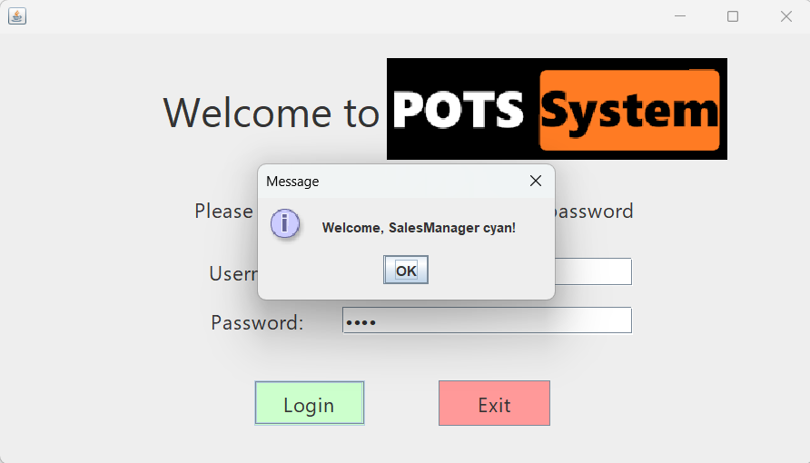

*Figure 2.1.3: Login Success*

If username and password are matches, it will pop up an welcome message and go to the specific role main page.

## 2.2 Administrator

*Figure 2.2.1: Administrator GUI*

After successfully login as admin, system will first lead to this admin main page. Since admin able to access everything, so there is all role function in this page and one extra function for admin only which is manage users.

*Figure 2.2.2: User Management GUI*

In manage user page, admin able to add, edit and delete users.

*Figure 2.2.3: Add New User*

To add new user, is required to fill username, password, select a role, gender and fill in email. After fill all the required fields and press add, it will successfully added the new user and pop up a new user added successfully message.

*Figure 2.2.4: Add User Validation*

If all the required field didn’t fill up or the username has already existed, then system will pop up error message.

*Figure 2.2.5: Edit User*

For editing, required at least select one of the users on the table to do editing. After selecting the user, the user detail will all display out and allow admin to do the editing, after finish editing press edit button then it will save the updated new user info and pop up success message.

*Figure 2.2.6: Edit User Validation*

If didn’t select at least one user from the table, system will pop up an error message.

*Figure 2.2.7: Delete User*

For delete, also required to select one user to perform delete. After select one user from table then press delete, then system will remove the user from file and pop up success message.

*Figure 2.2.7: Delete User Validation*

If didn’t select a user to delete, then system will pop up an error message and ask to select a user.

## 2.3 Finance Manager

*Figure 2.3.1: Finance Manager GUI*

After a successful login as finance manager, system will first lead to this finance manager main page. Finance manager can only verify purchase orders, check stock status which is headed by inventory manager and also make payment for purchase orders based on several payment methods to choose from

*Figure 2.3.2: Verify Purchase Orders*

In verify purchase orders for payment page, the finance manager can choose to approve or reject purchase orders or just leave it as pending as they wish. Or the finance manager can go back to the finance manager main page

*Figure 2.3.3: Approve Purchase Orders Validation*

When the approve button is clicked without selecting an entry, a warning message will appear suggesting selecting a row to change the status from pending to approve

*Figure 2.3.3: Reject Purchase Orders Validation*

When the reject button is clicked without selecting an entry, a warning message will appear suggesting selecting a row to change the status from pending to reject

*Figure 2.3.4: Purchase Orders Approved*

When selecting the 1st row entry as an example where the purchase order’s status has shown that it’s approved and then the approve button is clicked, a warning message will show that it has already been approved

*Figure 2.3.5: Purchase Orders Rejected*

When selecting the 4th row entry as an example where the purchase order’s status has shown that it’s rejected earlier and then the reject button is clicked, a warning message will show that it has already been rejected

*Figure 2.3.6: Approved Purchase Orders Validation*

When selecting an entry for example the first row, the status from pending to approved will be updated automatically when the approve button is clicked

*Figure 2.3.6: Rejected Purchase Orders Validation*

When selecting an entry for example the first row, the status from pending to rejected will be updated automatically when the reject button is clicked

*Figure 2.3.7: View Items List*

In Check stock status page, the finance manager can look on the table as displayed and updated by the inventory manager. Paid Date and Paid Time is set to Null default as the payment has not been done yet. Status is also set to default as Not Paid

*Figure 2.3.8: Make Payment GUI*

In Make Payment page, the finance manager can choose a payment method to pay for the purchase orders. Payment methods include cash, E-Wallet, Debit/Credit

*Figure 2.3.9: Make Payment Validation*

When any 1 of the payment method buttons are clicked without selecting an entry, a warning message will appear suggesting selecting a row to complete payment (transaction)

*Figure 2.3.10: Make Payment (Cash)*

When selecting the 1st row entry as an example and the “Pay by Cash” button is clicked, it would pop up a message that the payment is successful and on top of that, it will mention the specific payment method. Also, the Date Paid And Time Paid Columns will be updated based on real time.

*Figure 2.3.11: Payment Validation*

When selecting the 1st row entry as an example where the purchase order’s status has shown that it’s been paid earlier and then any of the payment method buttons are clicked, a warning validation message will show that payment is already done

*Figure 2.3.12: Payment Validation (E-Wallet)*

When selecting the 2nd row entry as an example and the “Pay by E-Wallet” button is clicked, it would pop up a message that the payment is successful and on top of that, it will mention the specific payment method. Also, the Date Paid and Time Paid Columns will be updated based on real time.

*Figure 2.3.13: Payment Validation (Debit/Credit)*

When selecting the 3rd row entry as an example and the “Pay by Debit/Credit” button is clicked, it would pop up a message that the payment is successful and on top of that, it will mention the specific payment method. Also, the Date Paid and Time Paid Columns will be updated based on real time.

## 2.4 Sales Manager

*Figure 2.4.1: Sales Manager GUI*

After successfully login to sales manager, here is the page it will going to which is sales manager main page.

*Figure 2.4.2: Success Create Purchase Requisition*

In create purchase requisition page, item name only accepts string and quantity only accept integer. Since we fill in correct data type, so the purchase requisition is created successfully. Requisition ID will be auto generated a unique ID, created date will auto assign the time purchase requisition created successfully and status will default as pending.

*Figure 2.4.3: Create Purchase Requisition Validation*

If didn’t fill anything inside the required field or fill in incorrect data type, it will pop up an error message.

*Figure 2.4.4: Success Edit Purchase Requisition*

Edit a purchase requisition required to first select a row of requisition from the table, then input the new data that wish to change. After press the edit button then it will pop up requisition updated successfully, and the table will also be updated.

*Figure 2.4.5: Delete Purchase Requisition Confirmation*

To delete a requisition, first need to select one of the requisitions from the table. Then press delete button. System will pop up a delete confirmation message, if press yes then the requisition will be deleted permanently but if press “no” then nothing happen.

*Figure 2.4.6: Success Delete Purchase Requisition*

After delete success, it will show a success message, and the requisition will remove from the table.

*Figure 2.4.7: Delete Purchase Requisition Validation*

Must be select one of the requisitions to delete, else it will pop up error message.

*Figure 2.4.8: Sales Entry GUI*

After enter sales entry page, there is a table to show all sales entry.

*Figure 2.4.9: Success Create Sales Entry*

When creating sales entry, if all the fields are fill with correct data type, it will pop up a success create sales entry message. Only item that exist in item inventory can be created a sales entry.

*Figure 2.4.10: Create Sales Entry Validation*

If fill in incorrect data type or left it empty, system will pop up an error message

*Figure 2.4.11: Success Edit Sales Entry*

For edit sales entry, at least select one sales entry from the table and fill the data that wish to change, and press edit. If all data is in correct data type, then sales entry successfully be edited.

*Figure 2.4.12: Edit Sales Entry Validation*

If didn’t select row to edit, then it will show an error message

*Figure 2.4.13: Delete Sales Entry Confirmation*

To delete a sales entry, first need to select one of the requisitions from the table. Then press delete button. System will pop up a delete confirmation message, if press yes then the sales entry will be deleted permanently but if press “no” then nothing happens.

*Figure 2.4.14: Success Delete Sales Entry*

After delete success, it will show a success message, and the selected sales entry will remove from the table.

*Figure 2.4.15: Delete Sales Entry Validation*

Must be select one of the sales entries to delete, else it will pop up error message.

*Figure 2.4.16: Generate Sales Report*

Generate sales report required to enter year and month. If the year or month doesn’t have any record, it will show nothing.

*Figure 2.4.17: Generate Sales Report Validation*

If left the field empty, system will display an error message

*Figure 2.4.18: View Item and Stock Level*

View item and stock level page will display all the items inside inventory which is manage by inventory manager.

*Figure 2.4.19: View Purchase Order*

View purchase order page will display all the purchase order made by purchase manage.

## 2.5 Purchase Manager

*Figure 2.5.1: Purchase Manager GUI*

After successfully login to Purchase Manager page, it will bring u to Purchase Manager main page which have view item, suppliers, requisitions, approve requisitions and purchase order buttons. The log out button is to log out from purchase manager main page and goes back to the selection page where other manager roles belong.

*Figure 2.5.2: View Items and stock level*

When click the view item button, it will display the table which have all the item in it.

*Figure 2.5.3: View Suppliers*

When click the view supplier button, it will display the table which have all the suppliers in it.

*Figure 2.5.4: View Requisitions*

When click the view requisition button, it will display the table which have all the requisitions in it.

*Figure 2.5.5: Success Approve Requisition*

After I selected a requisition to approve, it will show a success message, and the status will change to approved.

*Figure 2.5.6: Approve requisition Validation*

If doesn’t select any requisition from the requisition table and select approve, it will pop out an error message.

*Figure 2.5.7: Success Rejected Requisition*

After I selected a requisition to reject, it will show a success message, and the status will change to rejected.

*Figure 2.5.8: Reject Requisition Validation*

If didn’t select any requisition from the table and select reject, it will show an error message

*Figure 2.5.9: Success Add Purchase Order*

If all the text fields have written in and select add, it will show a success message and it will add the purchase order into the table.

*Figure 2.5.10: Add Purchase Order Validation*

If there is nothing written in the text fields, it will show an error message which ask to fill out the fields before adding.

*Figure 2.5.11: Edit Purchase Order Confirmation*

After filling out the fields and wanted to edit of the row, it will pop up a message saying whether yes or no to edit it.

*Figure 2.5.12: Success Edit Purchase Order*

If yes, it will show a success message saying that the purchase order is updated in the table. If no, there will be nothing happen.

*Figure 2.5.13: Edit Purchase Order Validation*

If there is nothing written in fields and select edit, it will show an error message.

*Figure 2.5.14: Delete Purchase Order Confirmation*

After filling the fields and select delete, it will pop up a message whether want to delete the purchase order or not.

*Figure 2.5.15: Success Delete Purchase Order*

If yes, it will show a success message, and the purchase order item will be deleted from the table. If no, it will show nothing happen.

*Figure 2.5.16: Delete Purchase Order Validation*

If didn’t fill in the order details in the fields and select delete, it will pop out an error message.

## 2.6 Inventory Manager

*Figure 2.6.1: Inventory Manager UI*

After login as Inventory Manager, the system will open this inventory manager main page. users can see the stock of all items on the table above first. The buttons below take the user to other pages with the facilities of the labelled functions. The logout button returns the user to the login page.

*Figure 2.6.2: Filter Table*

On the main page, there is a filter to arrange the table according to the selected category. This helps Users find the information they need efficiently.

*Figure 2.6.3: Manage Stock UI*

In this page, users can see the stock level and reorder level of all items. Users can edit the stock level & reorder level or remove items freely. Users can also choose a supplier for each item.

*Figure 2.6.4: Edit Stock Validation*

This message appears to remind the user that after editing the stock level the payment status of the edited item will be reset to not paid.

*Figure 2.6.5: Select Edit Stock Validation*

This message appears to let the user know they must select a row to edit before editing.

*Figure 2.6.6: Success Edit Stock Entry*

This message tells the user the selected stock has been edited successfully.

*Figure 2.6.7: Add New Items UI*

On the Add New Items page, users can add new items by filling the fields above. All fields must be filled out to add a new item.

*Figure 2.6.8: Add New Items Validation*

This message occurs whenever the user attempts to add a new item without filling all the fields,

*Figure 2.6.9: Successful New Item Added*

This message is displayed to tell the user the item was added successfully to the table.

*Figure 2.6.10: Manage Item UI*

On the Manage Item page, users can edit the name, price and description of the items currently in the stock table. Users must first select a row to edit then change the data in the fields.

*Figure 2.6.11: Edit Item Validation*

This message appears to remind the user that after editing the item information the payment status of the edited item will be reset to not paid.

*Figure 2.6.12: Select Edit Item Validation*

This message appears to let the user know they must select an item to edit before editing.

*Figure 2.6.13: Success Edit Item*

This message tells the user the selected item details has been edited successfully

*Figure 2.6.14: Manage Supplier UI*

On the Manage Supplier page, users can add, delete and edit the suppliers. The currently partnered suppliers are displayed in the table.

*Figure 2.6.15: Select Delete Supplier Validation*

This message appears to let the user know they must select a supplier to delete.

*Figure 2.6.16: Add Supplier Validation*

This message appears to let the user know they must fill all fields to add a new supplier.

*Figure 2.6.17: Select Edit Supplier Validation*

This message appears to let the user know they must select a supplier to edit before editing.

*Figure 2.6.18: Delete Supplier Validation*

This message is displayed to request user confirmation to delete a supplier.

*Figure 2.6.19: Success Delete Supplier*

This message tells the user the selected supplier has been deleted successfully.

*Figure 2.6.20: Success Add Supplier*

This message tells the user the supplier has been added successfully.

*Figure 2.6.21: Success Edit Supplier*

This message tells the user the selected supplier has been edited successfully.

# 3 Object Oriented Concepts

## 3.1 Encapsulation

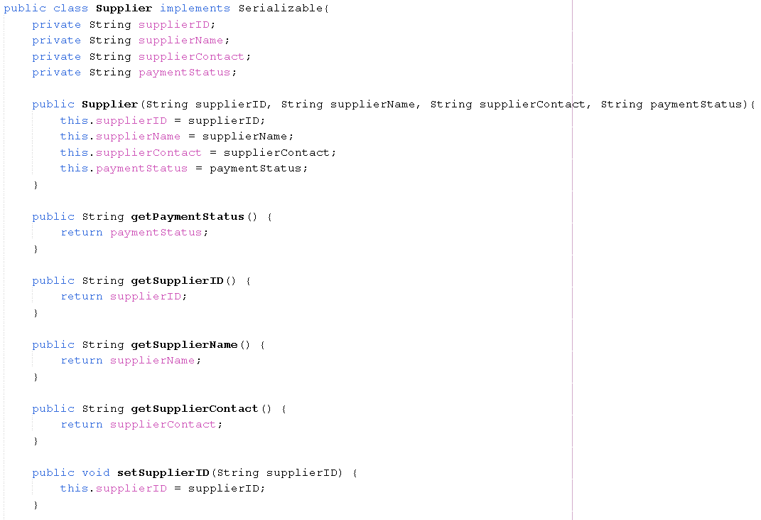

Encapsulation refers to the concept of storing attributes and methods inside a class so that when an object of the class is created, the methods can be called to access the attributes without changing the values. This shows the methods & attributes being declared in the Supplier class.

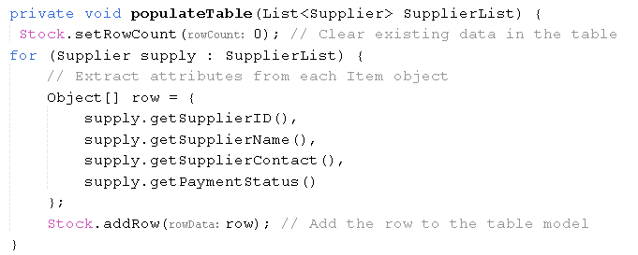

This example shows several get() methods being called from the Supplier class to access the attributes shown.

## 3.2 Inheritance

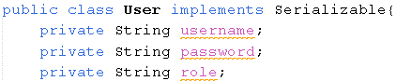

Inheritance occurs when a class(childclass/subclass) extends another class(parentclass/superclass). In this example the superclass is the User class

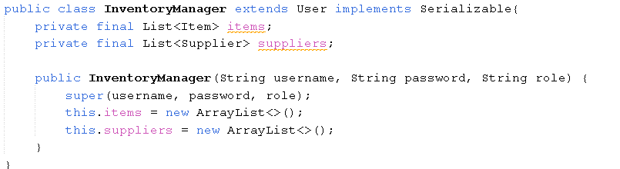

The class InventoryManager extends the User class which makes it the subclass.

## 3.3 Polymorphism

**Overloading**

Overloaded constructors in sales manager class, this constructor initialize a sales manager object with details like username, password, role, gender and email. For the default constructors, when there are no arguments provided but needed a placeholder sales manager object, java will use the default constructors.

## 3.4 Interface

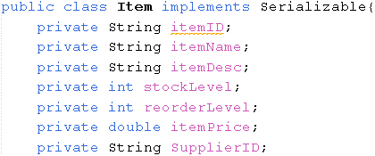

Interfaces help to make code reusable. These contain constants and methods that the class is required to implement unless the class is an abstract class. The example shows the Item class implementing the Serializable interface, which enables objects of this class to be written and read from a text file.

# 4 Additional Features

## 4.1 Stock Filtering

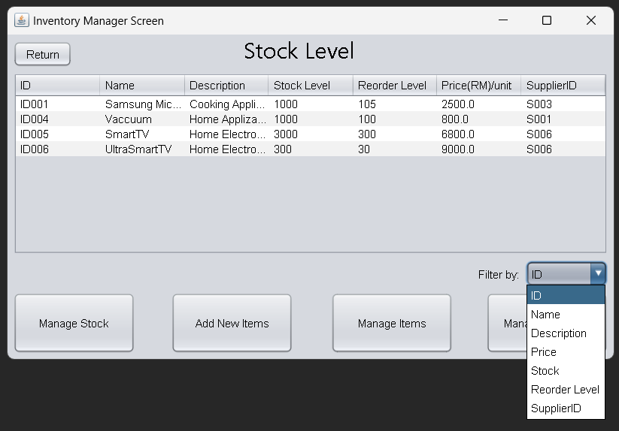The filtering function in the Inventory Manager user interface allows users to filter the displayed list of items according to the selected attribute such as Stock Level, Nam**e**, or Price

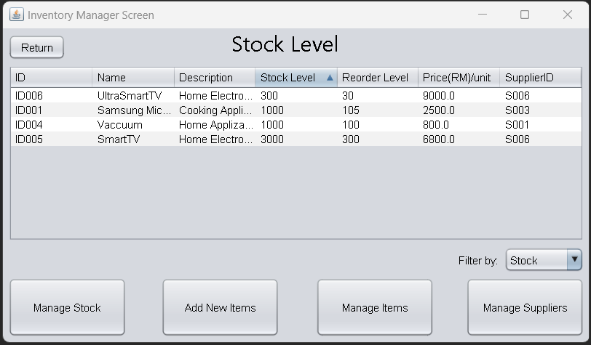This figure shows the rows in the table arranged in increasing order according to the Stock Level Column.

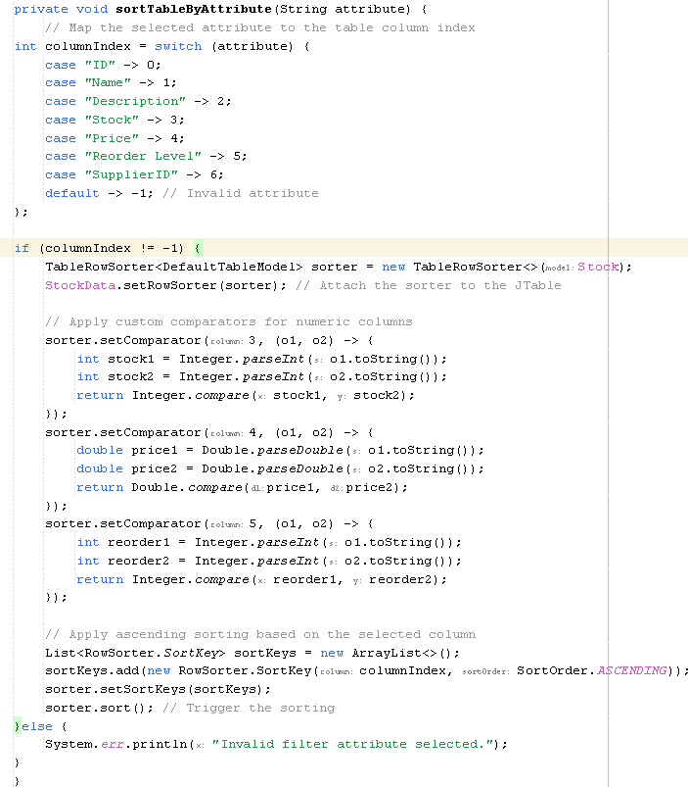

This figure shows the code of the filtering function. The sortTableByAttribute() method creates a TableRowSorter<> object to help sort the table. The integer columnIndex is checked to set up a switch case that is readable for humans. The code makes custom comparators for the filter to function for the non-String data types. For example, in case 3, the stock level is used so the comparator needs to account for integers. Finally, the sortKeys array list adds the row sorter in order of the selected columnIndex case and arranges the categories of attributes in ascending order.

## 4.2 Auto generate unique ID

To make sure every Purchase Requisition ID is unique and no repeat, I use take the current time and convert to milli to represent a unique ID and auto assign for every purchase requisition that created.

# 5 Limitations

1) Error Handling and File Management: The system currently relies on static data files for storing and managing information. This approach the issues such as file corruption, access errors and limited scalability. Furthermore, the error handling mechanisms lack robustness, potentially leading to unclear error messages or difficulties in troubleshooting sudden issues.

2) Scalability and Flexibility: The reliance on static data files and the absence of a dynamic database or cloud-based result limit the system’s capability to handle larger datasets or support multiple users. This can make the system less suitable for organizations taking real-time data updates or integration with other systems.

3) Security Gaps: The system doesn't incorporate advanced security features such as encryption, secure login sessions or comprehensive validation checks. For example, sensitive operations like managing user accounts, sales reports and financial data are potentially vulnerable to unauthorized access or data breaches due to the lack of encryption and other security layers.

4) User Interface Limitations: While the system provides functionalities for various roles (such as administrators, sales managers and finance managers), the user interface may have advanced features like dynamic dashboards or interactive visualizations which could enhance the user experience and improve overall effectiveness.

5) Dependency on Manual Inputs: Many processes within the system require manual inputs, such as creating records, managing stock levels and generating reports. This reliance increases the liability of human errors which could affect the accuracy and reliability of the data.

Addressing these limitations in future iterations will significantly improve the system's reliability, usability and adaptability. Integrating dynamic data storage solutions, enhancing security protocols, refining error-handling mechanisms and helping the user interface can make the system better equipped to handle more complex and demanding real- world scenarios.

# 6 Conclusion

The system’s design relies heavily on the use of Object-Oriented Programming (OOP) principles and clear role-based functionalities to streamline various administrative and functional processes. By applying concepts such as encapsulation, inheritance and polymorphism, the system ensures modularity, scalability and ease of maintenance.

The system supports multiple user roles including administrators, sales managers, purchase managers, inventory managers, and finance managers which each equipped with tools suited to their specific responsibilities. For example, sales managers can manage sales entries, generate sales reports and monitor stock levels which help ensure smooth sales operations and effective inventory operations. Additionally, features like auto-generated unique IDs and stock filtering can enhance the functionality and user efficiency.

Overall, this system serves as a strong example of how OOP principles and thoughtful design can address real-world challenges. By giving a modular organized framework, it lays the groundwork for future improvements and is well-suited to operational management tasks. With other refinement, it can evolve into a more dynamic and secure solution for increasingly complex requirements.

# 7 References

* *W3Schools.com*. (n.d.). <https://www.w3schools.com/java/java_methods_overloading.asp>
* *W3Schools.com*. (n.d.-b). <https://www.w3schools.com/java/java_encapsulation.asp>
* *W3Schools.com*. (n.d.-c). <https://www.w3schools.com/java/java_inheritance.asp>
* Obregon, A. (2023, November 26). Mastering Java OOP: A Full Guide | Medium. *Medium*. <https://medium.com/@AlexanderObregon/a-guide-to-object-oriented-programming-in-java-89dc4544837f>
* Askar, P., & Davenport, D. (n.d.). *An Investigation of Factors Related to Self-Efficacy for Java Programming among Engineering Students.* <https://eric.ed.gov/?id=ED503900>
* Rasala, R., Raab, J., & Proulx, V. K. (2001). Java power tools. *ACM SIGCSE Bulletin*, *33*(1), 297–301. <https://doi.org/10.1145/366413.364606>